System Use Case Specification
SDMP
UC – Music Playback

Origin/Author : Cameron Samuels

Version : 0.1

Document Control

Document History
Version | Date | Description | Author
0.1 | 31/01/2022 | SDMP – initial version. | Cameron Samuels

Table of Contents
1. Brief Description 4
2. Use Case Diagram 4
3. Flow of Events 4
3.1 Basic Flow 4
3.2 Alternate Flows 5
4. Special Requirements 5
5. Pre-conditions 5
6. Post-conditions 5
7. Extension Points 5
8. Business Rules 5
9. Business Entities 6
9.1 Input – Parameter 6
9.2 Output – Images/Text 6
9.3 Output – Audio 6

Music Playback

Brief Description
This use case describes the process to play audio files using the interface.

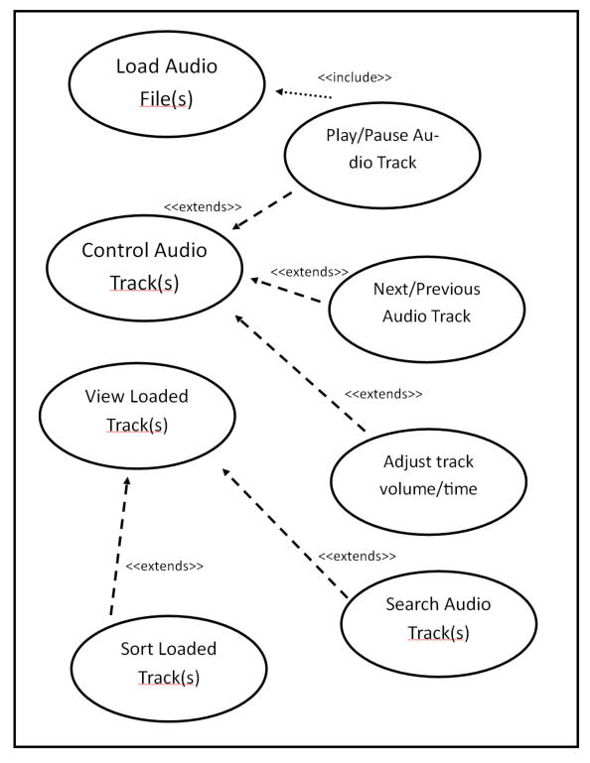

Use Case Diagram
Customer

Flow of Events

Basic Flow
- The use case starts when the interface is initiated by the user.
- The user adds one or more audio files to the interface. (see 8.1, 8.2 Business Rules)
- The system automatically plays an audio track. (see 8.3 Business Rules)
- The user opens the playlist and see’s all added tracks. (see 9.2 Output – Images/Text , 8.2 Business Rules)
- The user manually controls the audio tracks including volume, time, shuffle, repeat and next/previous track.
- Use case ends.

Alternate Flows
None.

Special Requirements
None.

Pre-conditions
None.

Post-conditions
None.

Extension Points
None.

Business Rules
No | Description
1 | Audio tracks are of one of the following file type:  - M4A  - FLAC  - MP3  - MP4  - WAV  - WMA  - AAC
2 | Audio tracks contain the following metadata:  - Album cover artwork  - Album name  - Track name  - Artist name
3 | Inputting audio track initiates play of:  - Audio file which is loaded into playlist

Business Entities

Input – Parameter
Item | D/O/M* | Format | Business Entity
Audio File | O | File Type see 8.1 Business Rules | FILEINPUT
Search | O | Alpha-Numeric Character | SEARCH
Play/Pause | O | Button click | PLAYPAUSE-TRACK
Previous Song | O | Button click | PREV-TRACK
Next Song | O | Button click | NEXT-TRACK
Shuffle | O | Button click | RANDOM-TRACK
Repeat Song | O | Button click | REPEAT-TRACK
*Display-only/Optional/Mandatory

Output – Images/Text

Item | Format and Validation | Business Entity
Album Artwork | Base64String – centre circle is populated – see 8.2 Business Rules | PICDATA
Track Name | Alpha-Numeric Characters – “Track Name” is replaced with Track Name, row is added to playlist table – see 8.2 Business Rules | TRACK_NAME, MUSICLIST
Track Artist | Alpha-Numeric Characters – “Track Artist” is replaced with Track Artist – see 8.2 Business Rules | TRACK_ARTIST
Album Name | Alpha-Numeric Characters – row is added to playlist table – see 8.2 Business Rules | MUSICLIST

Output – Audio

Item | Format and Validation | Business Entity
Audio Track | File Type (see 8.1 Business Rules) – audio is output from the interface | PLAYTRACK()

